**Lab 10: Simple Design using Multiple IPs**

**Exercise 10.1:** Design and implement a unit which computes O = (A*B) + (C*D) using Vivado IPs. A, B, C and D are 2-bit inputs. O is a 5-bit output. Implement the design on FPGA and show the outputs using on board LEDs. Assume inputs are connected DIP switches.

**Pin Information:**

**A[1:0] 🡪 [M15, H17]**

**B[1:0] 🡪 [H18, H19]**

**C[1:0] 🡪 [F21, H22]**

**D[1:0] 🡪 [F22, G22]**

**O[4:0] 🡪 [V22, U21, U22, T21, T22]**

1. **Copy the image of the IP based design:**

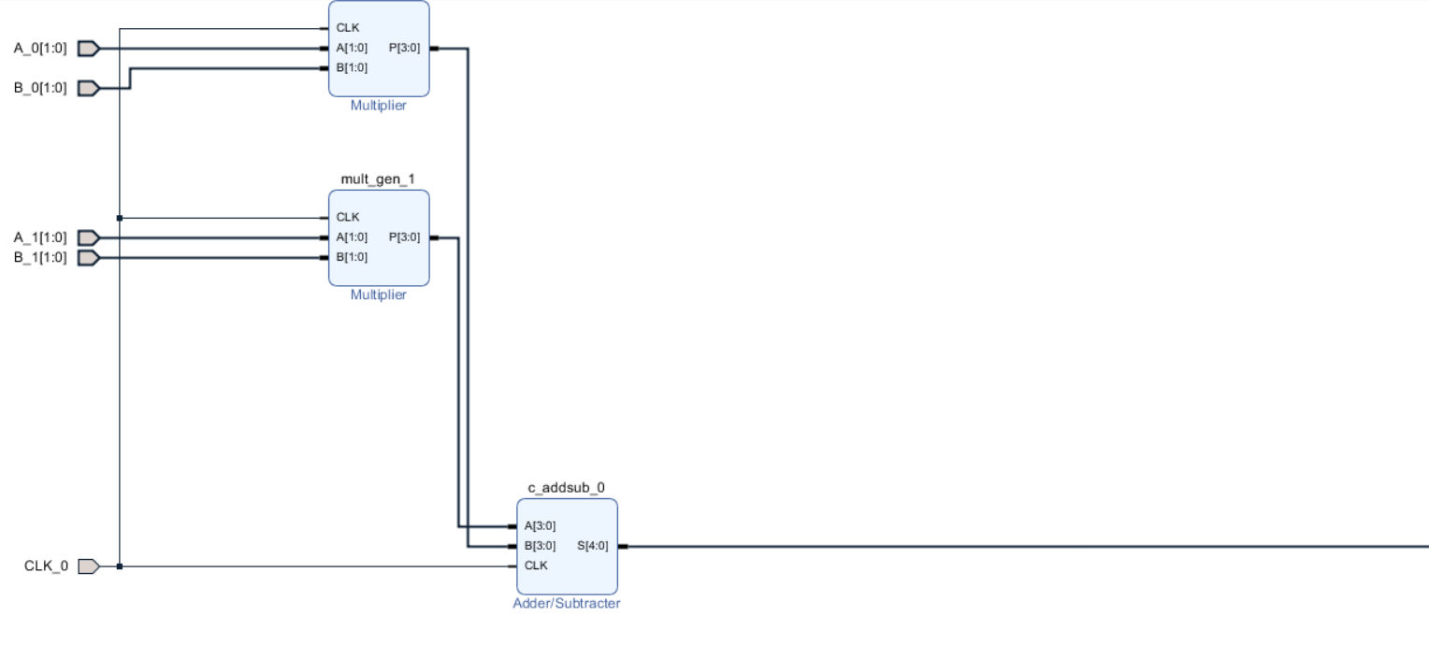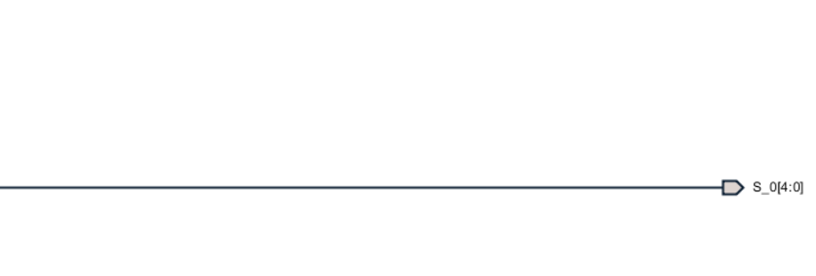S[4:0] is the final output.

1. Write appropriate test bench and test your module.

**Question: Paste the image test bench code.**

Answer: 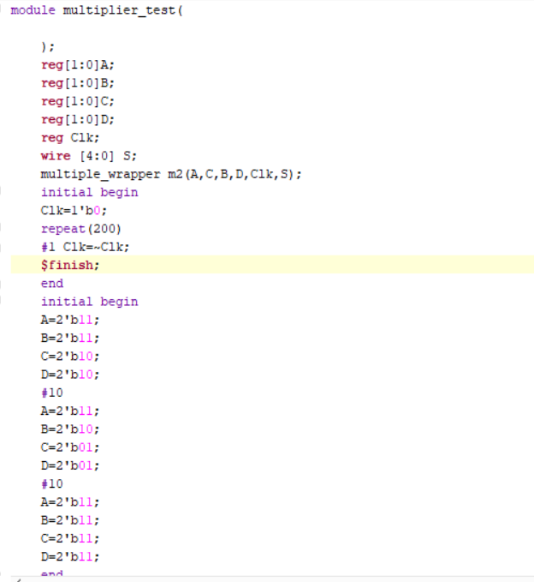

**Question: Paste the image showing the simulated waveforms.**

Answer: 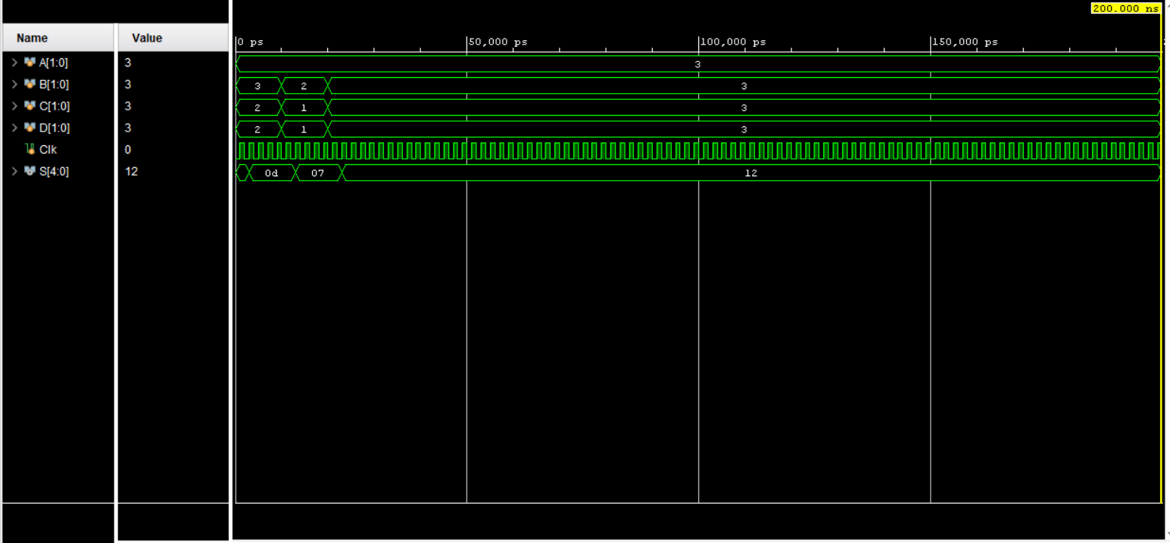

1. Plan your I/O mapping (using **I/O planning** option) such that actual input **Clk** is connected to internal clock pin **Y9,** all inputs connected to DIP switches and outputs are connected to LEDs (Refer to old documents or CMS for Pin information). Save the mapping information as **design_1.xdc**.
2. Synthesize (**Run Synthesis**) and Implement the design (**Run Implementation)**.

**Question: Paste the image showing the schematic after synthesis.**

Answer: 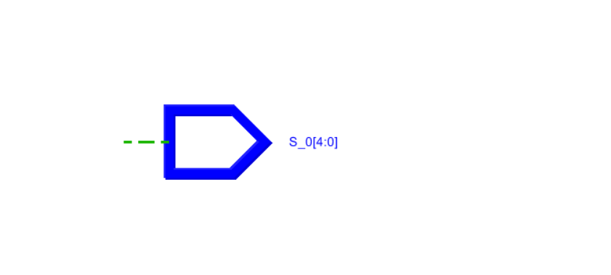

**Question: Check the summary report and report hardware utilization for the implementation.** (Note the utilization in your observation book)

Answer: 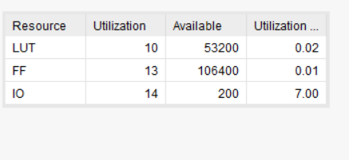7.03 percent

1. **Generate Bitstream** and port your design on to FPGA (**Open Hardware Manager**🡪 **New Target**🡪… **Program Device**)
2. **Check the output on FPGA.**

**List the concepts you learnt from this lab (Conclusions/Observations)**

Answer: I learnt the implementation of a adder(5 bit) where the inputs are producs of 2 bit numbers A,B,C,D using Xilinx IP, where it works exactly like the generation of a conventional Verilog code however in the IP there are inbuilt blocks which serve the same purpose. Then there is a wrapper which converts this block into a Verilog code automatically. We should provide a testbench to check whether the block is working as intended. Then in the I/O Planning we need to map the input and output ports to DIPs(the LED lights) so that we can view our results. Rest of the procedure is similar to the earlier labs wrt to running synthesis,implementation,generating bitstream.